

|  |  |  |  |  |  |  |  |  |
| --- | --- | --- | --- | --- | --- | --- | --- | --- |
|  | | | | | | | | |
|  | | Movie Recommendation System | | | | |  | |
|  |  | | | | | | |  |
|  | | | |  |  | | | |
|  | | | | Sufyan Ahmad 20-NTU-CS-1135  **Saad Usman**  20-NTU-CS-1134 |  | | | |
|  | | | | 12-06-2023—Introduction to Artificial Intelligence—Mam Sajida Parveen |  | | | |
|  | | |  | | |  | | |



|  |  |  |  |  |  |  |  |  |
| --- | --- | --- | --- | --- | --- | --- | --- | --- |
|  |  | | |  |  | | |  |
|  | INTRODUCTION | | | | | | |  |
|  |  | | |  |  | | |  |
|  |  | |  | | |  | |  |
|  |  |  | The code provided implements a simple movie recommender system using a content-based filtering methodology. Recommender systems play a crucial role in helping users discover relevant items in various domains, such as movies, music, products, and more. In this case, the focus is on recommending movies to users based on their content or characteristics.  Content-based filtering is a popular methodology in recommender systems that relies on analyzing the attributes or content of items to make recommendations. Instead of relying on explicit user feedback or collaborative filtering techniques, content-based filtering assesses the similarity between items based on their features and recommends items that are like those the user has shown interest in.  The code utilizes data from The Movie Database (TMDb) API to retrieve movie information, including titles, genres, and poster images. It also leverages precomputed similarity values between movies, which are typically calculated using techniques like cosine similarity or Euclidean distance. These similarity values capture the similarity in content between different movies, enabling the identification of movies that share similar characteristics.  When a user selects a movie from the provided dropdown, the code uses the selected movie as a query to find the most similar movies based on the precomputed similarity matrix. The top similar movies are then recommended to the user. To enhance the user experience, the code fetches and displays the movie posters of the recommended movies by making additional API calls to TMDb.  The resulting movie recommender system aims to provide personalized recommendations to users based on the content or attributes of movies. By analyzing the similarities between movies and leveraging their features, the system helps users discover new movies that align with their preferences, genres of interest, or other content-related characteristics.  It's important to note that the code provided is a simplified implementation and can be further expanded or enhanced depending on specific requirements or additional data sources. However, it serves as a starting point for understanding the content-based filtering methodology in movie recommendation systems. | | |  |  |  |
|  | | | | |
|  |  |  |  |
|  |  |



|  |  |  |  |  |  |  |  |  |
| --- | --- | --- | --- | --- | --- | --- | --- | --- |
|  | |  |  | | |  |  | |
|  | | OBJECTIVE | | | | |  | |
|  | |  |  | | |  |  | |
|  | The objective of the movie recommender system implemented in the provided code is to assist users in discovering relevant and personalized movie recommendations based on the content or characteristics of movies. The system aims to address the challenge of information overload by narrowing down the vast collection of movies and suggesting a subset of movies that are likely to be of interest to individual users.  Specifically, the objectives of the movie recommender system are as follows:  **1. Personalized Recommendations:**  The system aims to provide personalized movie recommendations tailored to each user's preferences. By analyzing the content or features of movies that users have shown interest in, the system identifies movies with similar attributes and suggests them as potential recommendations.  **2. Content-Based Filtering:**  The system utilizes a content-based filtering approach, which focuses on the characteristics or content of movies rather than relying on explicit user feedback or collaborative filtering techniques. By considering movie titles, genres, and possibly other attributes such as actors or directors, the system identifies movies that share similar content and recommends them to users.  **3. Enhanced User Experience:**  The system strives to enhance the user experience by fetching and displaying movie posters alongside the recommended movie titles. Visual representations help users quickly grasp the overall look and feel of the recommended movies, making it easier to evaluate and decide whether they want to explore them further.  **4. Discovery of Relevant Movies:**  The primary objective of the movie recommender system is to assist users in discovering movies they might not have encountered otherwise. By leveraging the content-based approach, the system identifies movies with similar characteristics to those the user has shown interest in, increasing the chances of finding new movies that align with the user's preferences and interests.  **5. Efficiency and Scalability:**  The code implementation aims to provide efficient and scalable recommendations by leveraging precomputed similarity values. By calculating and storing the similarity matrix in advance, the system can quickly retrieve and present recommendations to users without the need for extensive computations in real-time.  Overall, the objective of the movie recommender system is to enhance the movie discovery process, provide personalized recommendations, and facilitate users in finding movies that align with their interests and preferences based on the content or characteristics of the movies. | | | | | | |  |
|  |  | | |  |

**MOTIVATION**

The motivation behind the movie recommender system implemented in the given code is to provide users with personalized and relevant movie recommendations based on their individual preferences and interests.

Here are some key motivations for building such a system:

**1. Enhancing Movie Discovery:**

The vast number of available movies can make it challenging for users to discover new and interesting titles. The recommender system aims to alleviate this issue by suggesting movies that align with the user's taste and preferences. It helps users explore a wider range of movies they might not have come across otherwise.

**2. Improved User Experience:**

By providing tailored recommendations, the system enhances the user experience by offering a curated selection of movies that are likely to be of interest. This personalized approach saves users time and effort in searching for movies and increases their satisfaction with the recommendation process.

**3. Increasing Engagement and Retention:**

Recommender systems can contribute to increased user engagement and retention on movie platforms or streaming services. By consistently offering relevant recommendations, the system encourages users to stay on the platform, discover new content, and potentially consume more movies.

**4. Addressing Information Overload:**

With the ever-growing amount of available movie options, users can easily become overwhelmed. The recommender system addresses the problem of information overload by presenting a manageable subset of movies that are tailored to the user's preferences. It helps users navigate through the vast collection and provides them with a more focused selection of movies to choose from.

**5. Content-Based Filtering Advantages:**

Content-based filtering, the methodology employed in the code, has several advantages. It does not rely on explicit user feedback or the need for large amounts of historical data, making it suitable for scenarios where user interactions are limited. Additionally, content-based filtering can offer recommendations based on specific content attributes, such as genres, which can be appealing to users with specific movie preferences.

Overall, the motivation behind the movie recommender system is to enhance the movie discovery process, improve user experience, address information overload, and ultimately provide users with personalized and relevant movie recommendations that align with their interests and preferences.

**DATASET DESCRIPTION**

**Datasets**

Explore, analyze, and share quality data.

Inside Kaggle you’ll find all the code & data you need to do your data science work. Use over 50,000 public datasets and 400,000 public notebooks to conquer any analysis in no time.

**Dataset Link:** <https://www.kaggle.com/tmdb/tmdb-movie-metadata?select=tmdb_5000_movies.csv>

The dataset used for the movie recommender system consists of movie information, including movie titles, movie IDs, and possibly other attributes like genres.

The dataset likely contains a collection of movies and their corresponding attributes, which are used to calculate the similarity matrix and generate recommendations. The similarity matrix captures the similarity or distance between movies based on their attributes, enabling the identification of similar movies.

Without further information or access to the dataset itself, it is difficult to provide a detailed description of the dataset used in the code. However, a typical movie dataset for a recommender system may include attributes such as:

**1. Movie Title:** The title or name of the movie.

**2. Movie ID:** A unique identifier for each movie.

**3. Genres:** The genre(s) of the movie, such as action, comedy, drama, etc.

4. Additional Attributes: Depending on the dataset, there may be additional attributes available, such as actors, directors, release year, ratings, or other descriptive features.

These attributes are utilized in the content-based filtering approach to calculate similarity values between movies and generate recommendations.

It is important to note that the specific dataset used in the code implementation may not be directly visible in the code snippet itself. The code may be loading the dataset from external files or retrieving it from a database using pickle. To obtain a more detailed dataset description, you may need to refer to the source from which the dataset was obtained or analyze the data files provided alongside the code.

**METHODOLOGY**

It implements a simple content-based movie recommender system using a methodology known as "content-based filtering." Content-based filtering recommends items to users based on the characteristics or content of the items themselves, rather than relying on user preferences or collaborative filtering.

Here's a brief overview of the methodology used in the code:

**1. Data Retrieval:**

The code retrieves movie data from an external API, specifically from The Movie Database (TMDb), using the movie ID.

**2. Similarity Calculation:**

The code loads precomputed similarity values between movies. This similarity matrix is typically calculated using techniques such as cosine similarity or Euclidean distance, which measure the similarity between the content or features of different movies.

**3. Recommendation Generation:**

When a user selects a movie from the dropdown, the code identifies the index of the selected movie in the movie list and retrieves the similarity values for that movie from the similarity matrix.

**4. Top Similar Movies:**

The code sorts the similarity values in descending order and selects the top similar movies, excluding the selected movie itself.

**5. Movie Poster Fetching:**

For each recommended movie, the code fetches the movie poster by making another API call to TMDb.

**6. Display:**

The code uses the Streamlit library to display the recommended movies' names and posters in a user-friendly format.

The methodology used here, content-based filtering, leverages movie metadata such as titles, genres, and possibly other features like actors or directors to identify similar movies. It does not consider user preferences or interactions with the system. Content-based filtering can be useful in situations where user-item interactions are limited or when recommendations based on item attributes are desired.

Please note that the specific details of the methodology, such as the features used for similarity calculation or the API endpoints and keys, may vary depending on the implementation and the data available.

**FLOW CHART**

**USE CASE DAIGRAM**

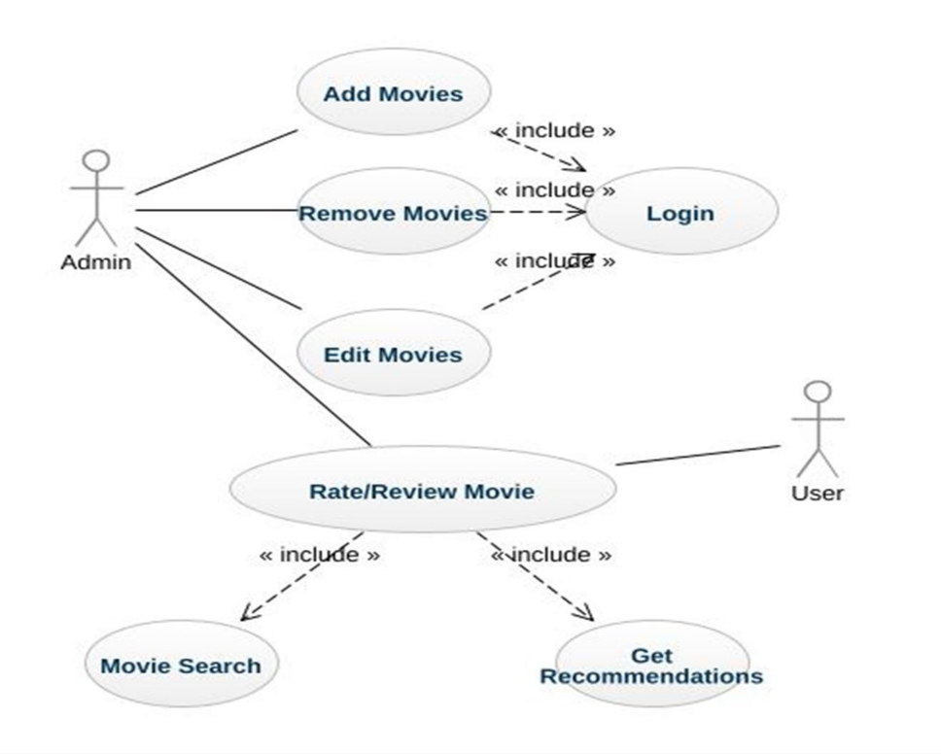

**WORKFLOW DAIGRAM**

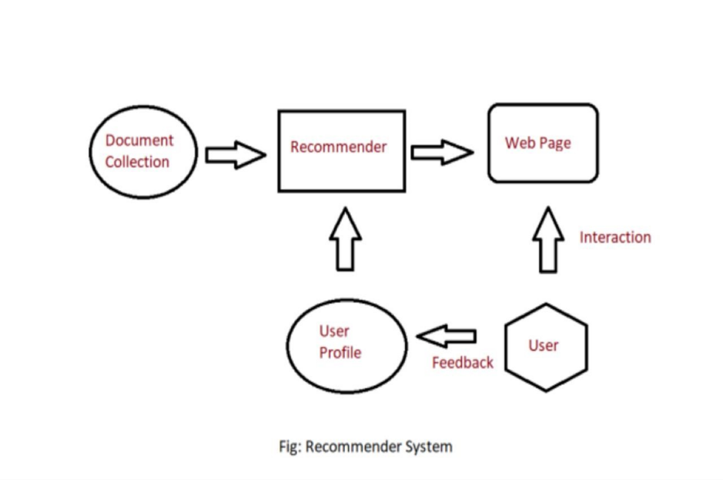

**FLOW CHART**

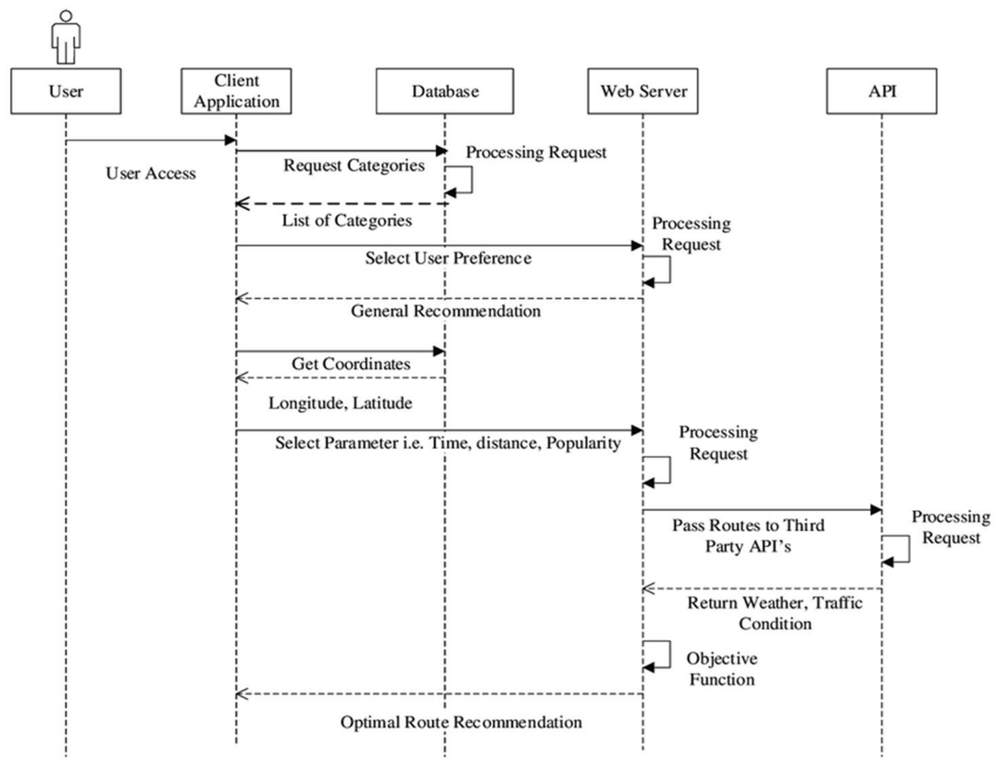

**ACTIVITY DAIGRAM**

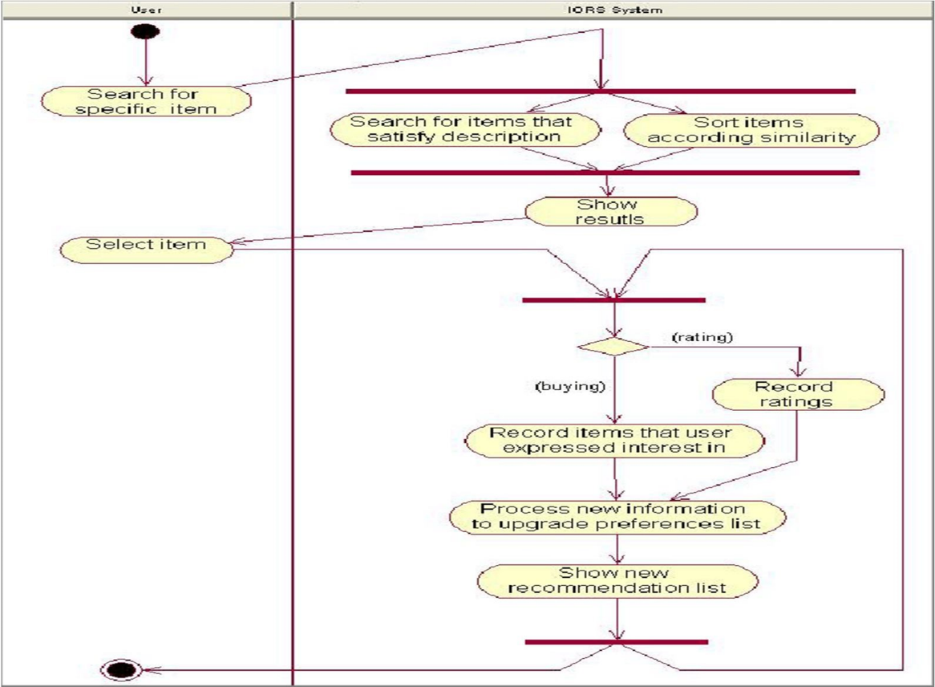

**LIBRARRIES**

The libraries that are used in the code are following.

* Panda
* Numpy
* Requests
* Ast
* Streamlit
* Pkl
* OS

**pickle:** Used for reading and writing Python objects to/from files, in this case, for loading the movie list and similarity data.

**requests:** Used for making HTTP requests to the API endpoint to fetch movie data.

**streamlit:** Used for creating the web application user interface and interactive components.

**Pandas:** Used for data manipulation and analysis. It provides data structures and functions for efficiently working with structured data, such as loading and manipulating the movie dataset.

**NumPy:** Used for numerical operations and array manipulation. It provides mathematical functions and arrays that enable efficient computations on large datasets, such as calculating similarity scores or performing array operations.

**Ast:** It stands for the Abstract Syntax Trees module in Python. However, it does not appear to be used in the provided code snippet. It might be an unused import statement or an oversight.

**OS:** Used for interacting with the operating system. It provides functions for file and directory operations, such as accessing files, directories, or checking the current working directory.

Therefore, based on the code snippet you provided, the libraries used are `Pandas`, `NumPy`, and `OS`.

**APPLICATIONS USED**

The applications that are used in the project are the following.

* PyCharm
* Jupyter Notebook
* Python
* Brower's (Google Chrome, Microsoft Edge)

**DETAIL OF MODEL TRAINING**

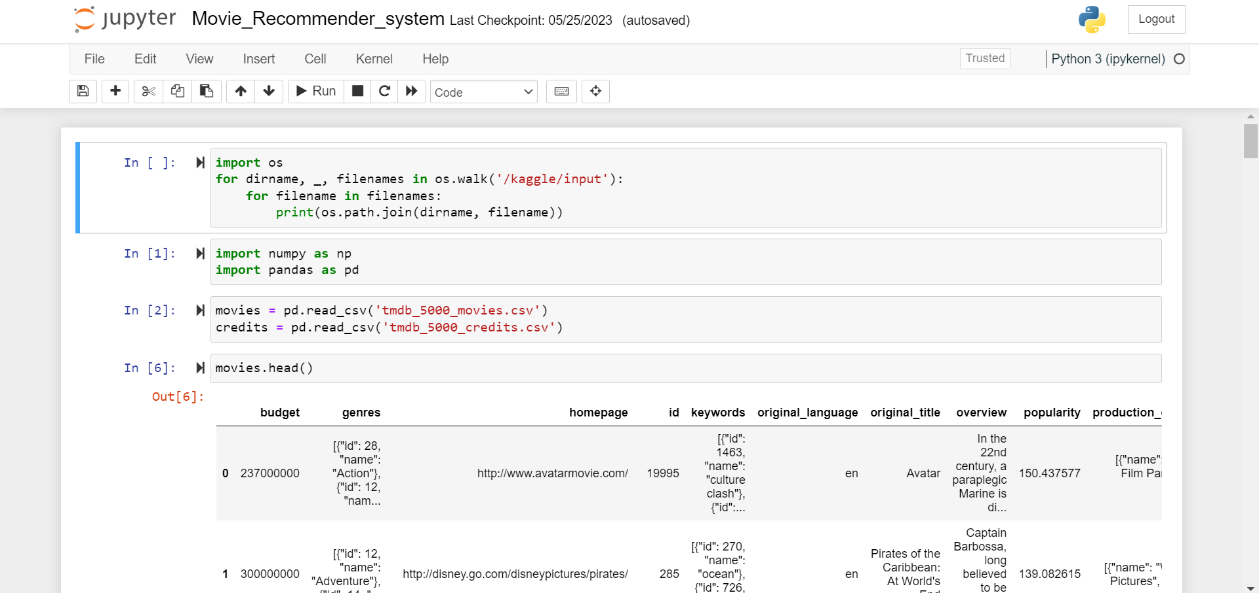

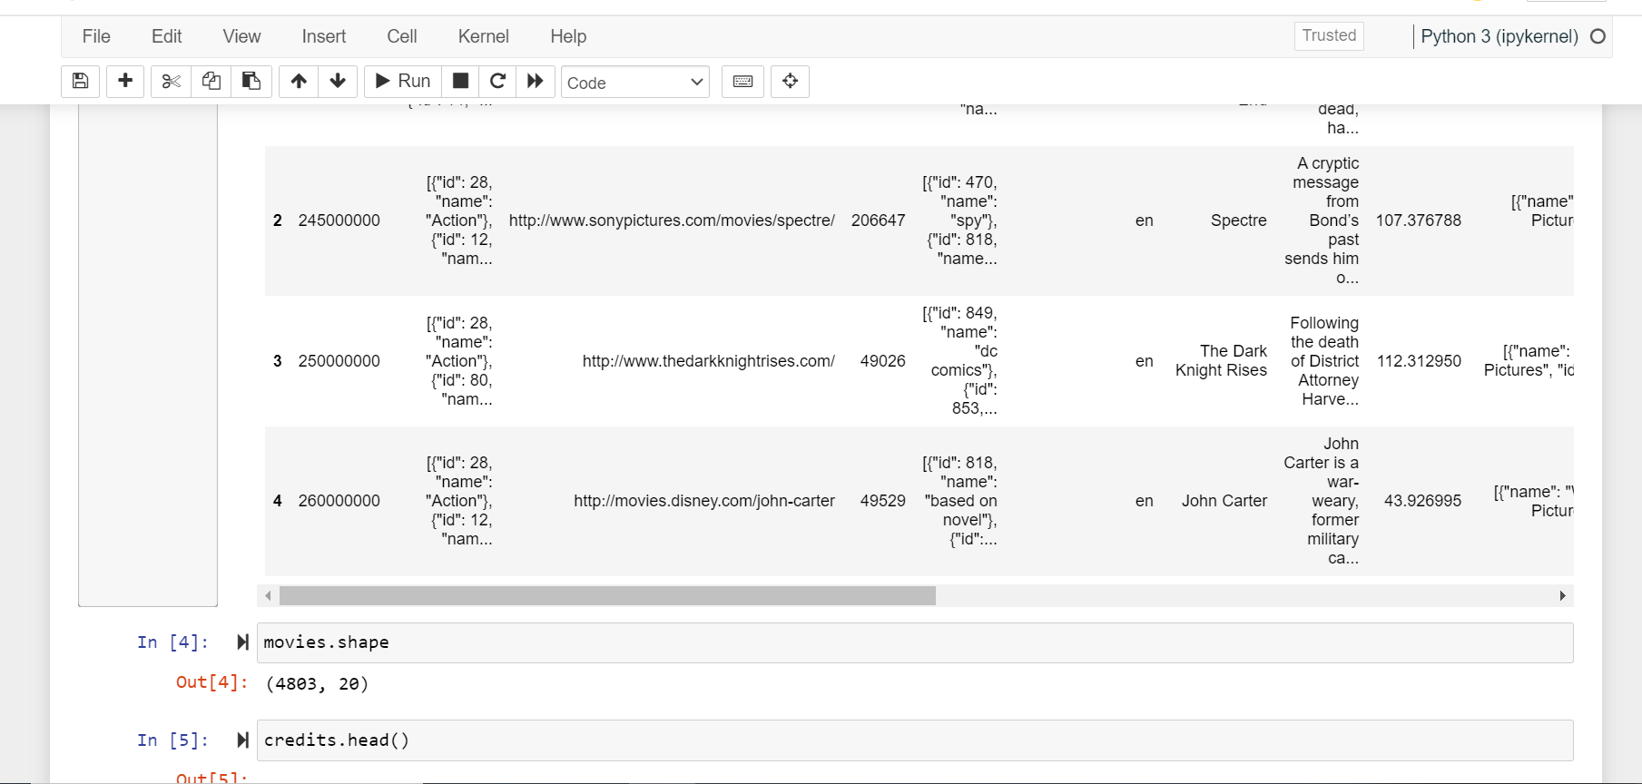

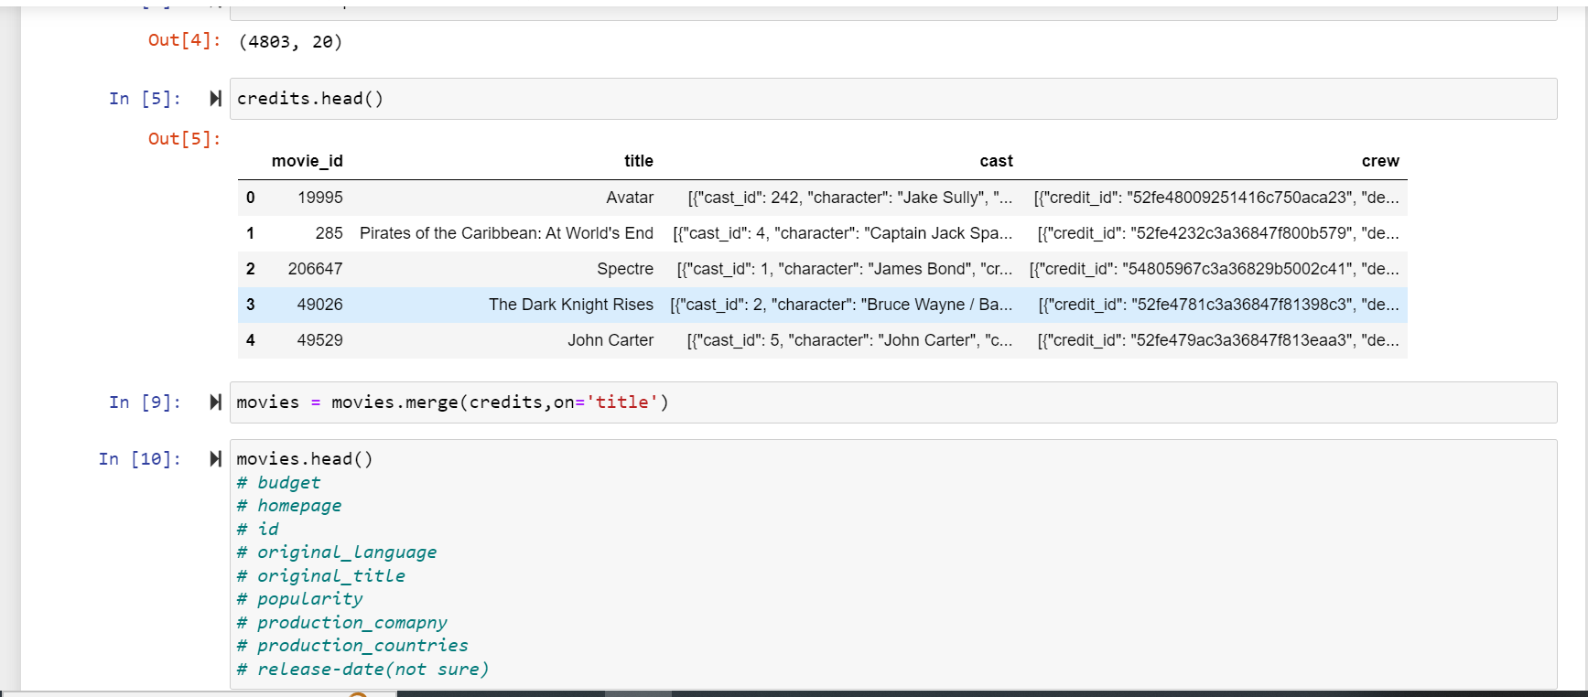

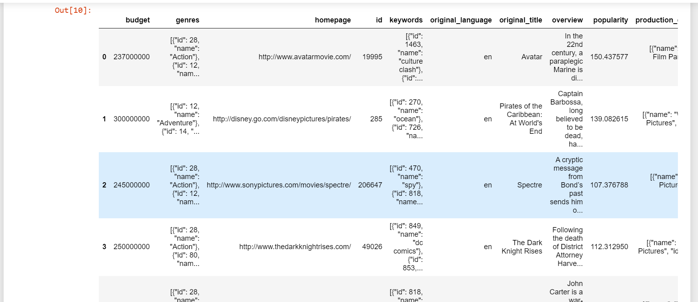

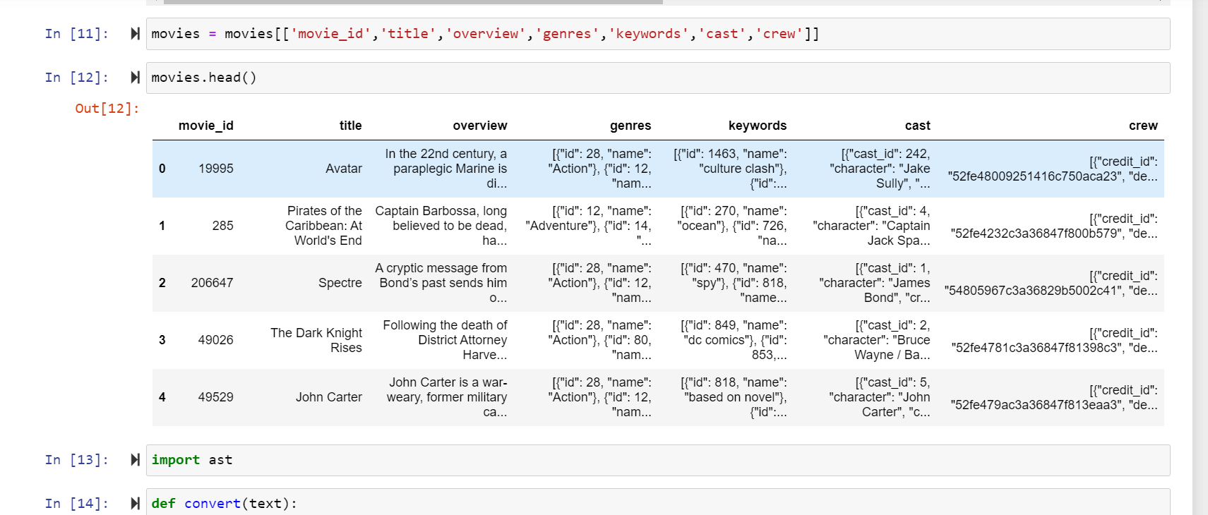

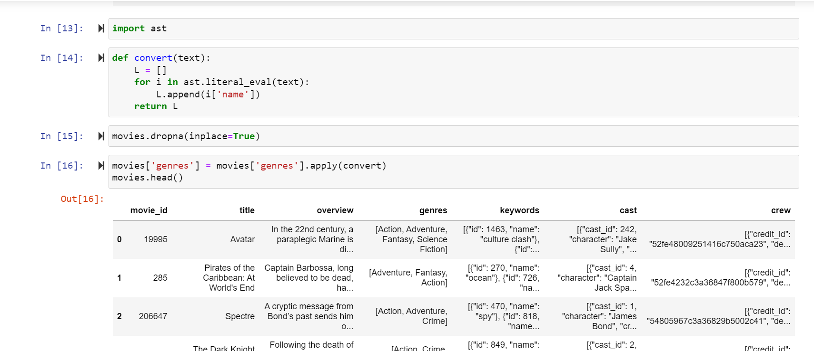

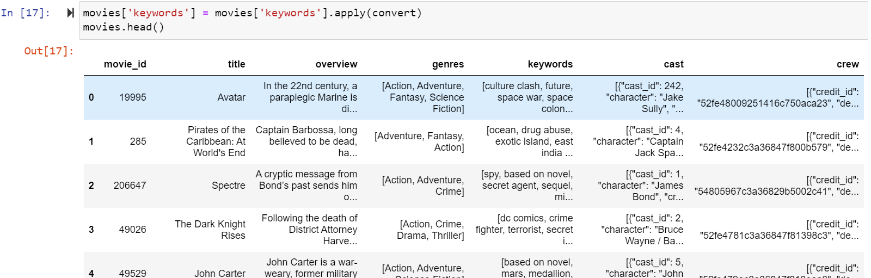

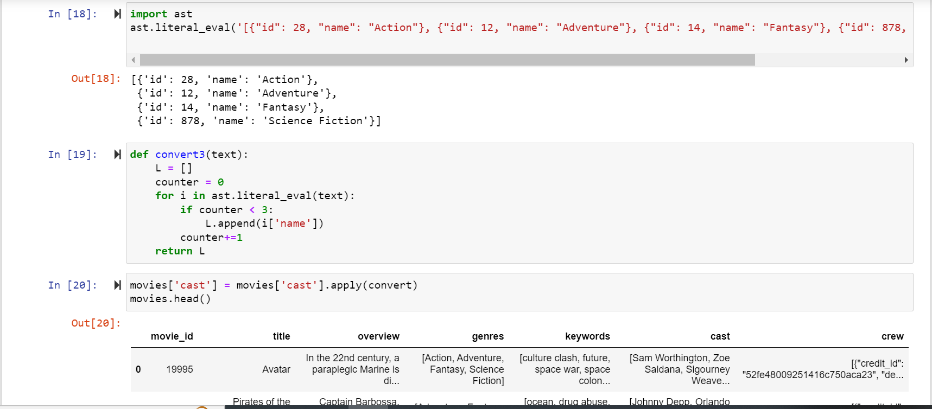

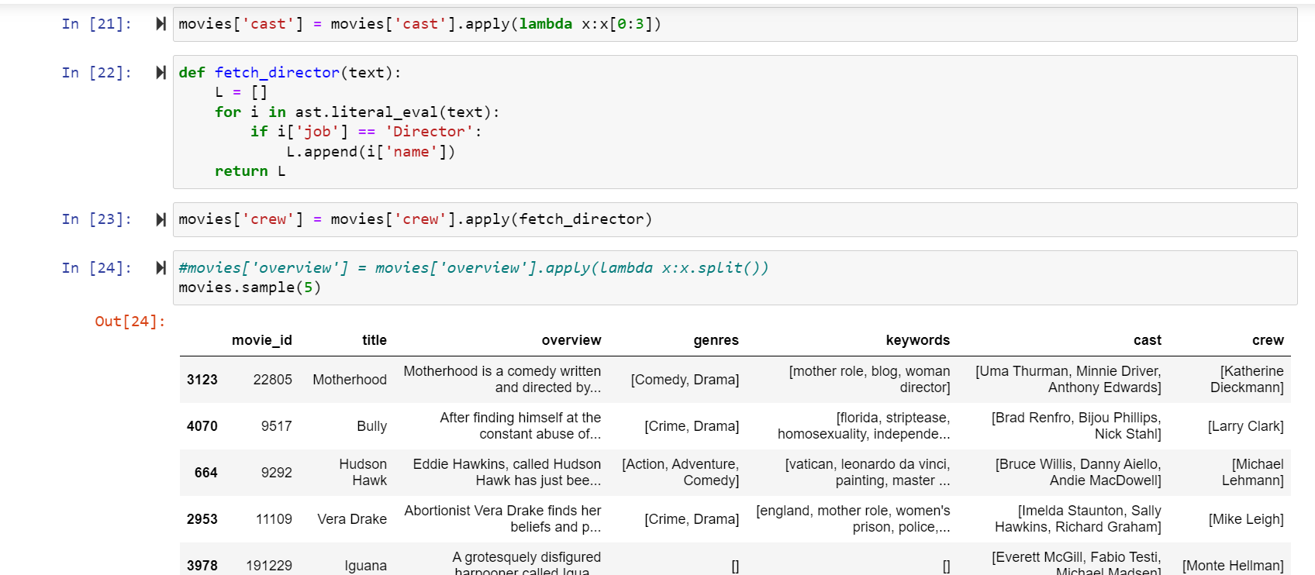

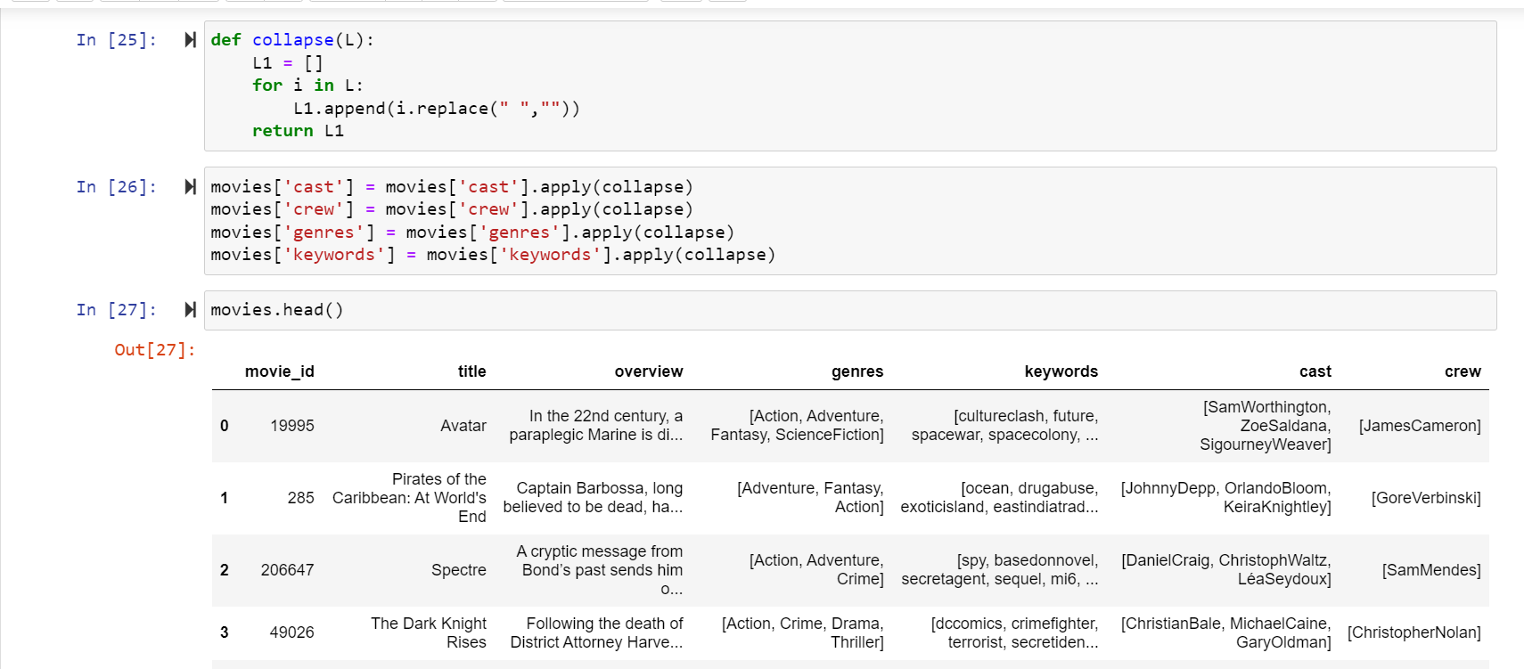

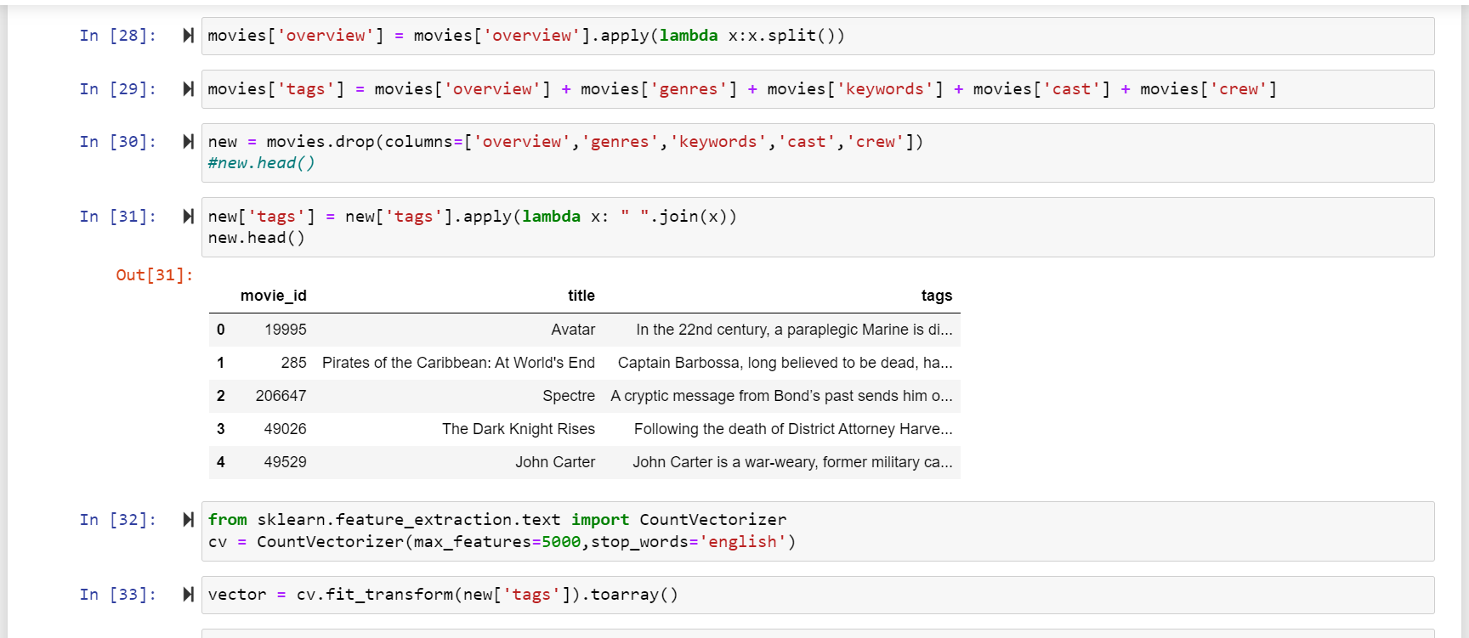

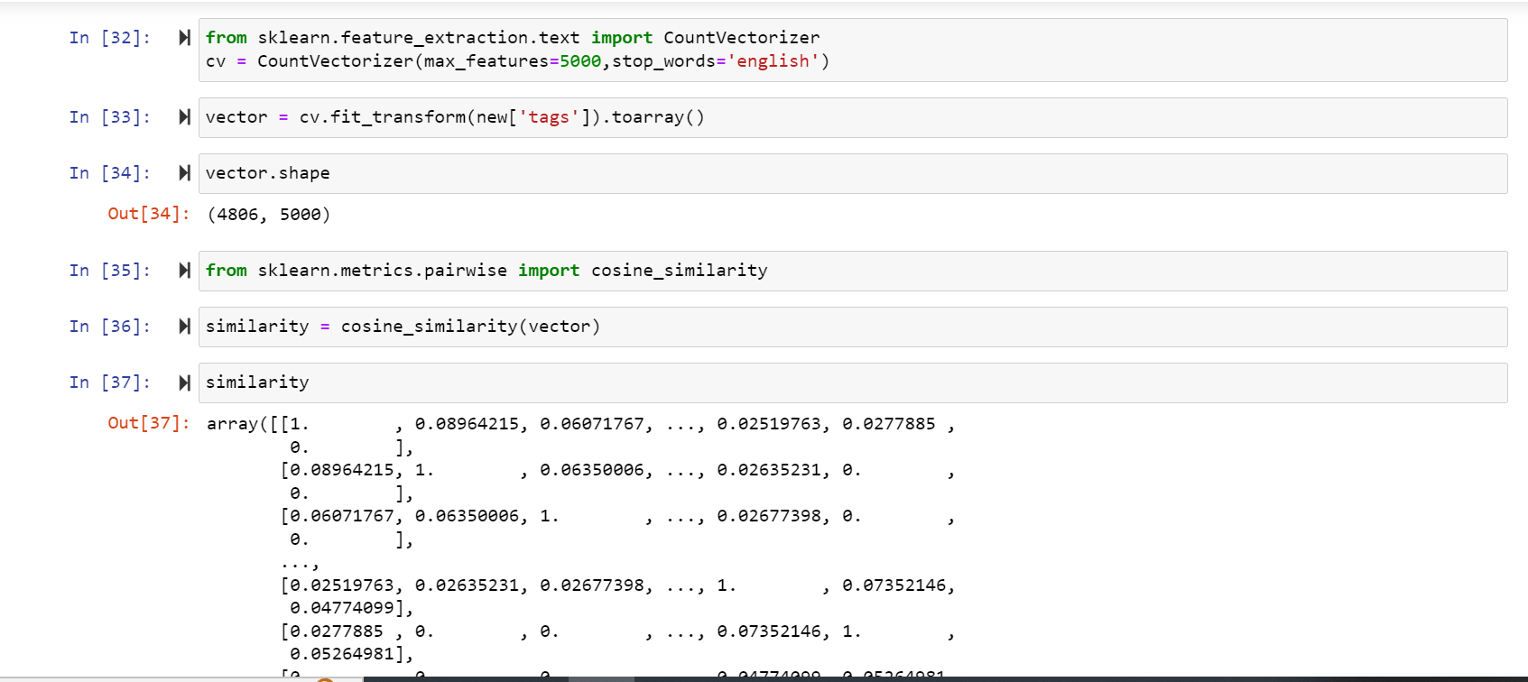

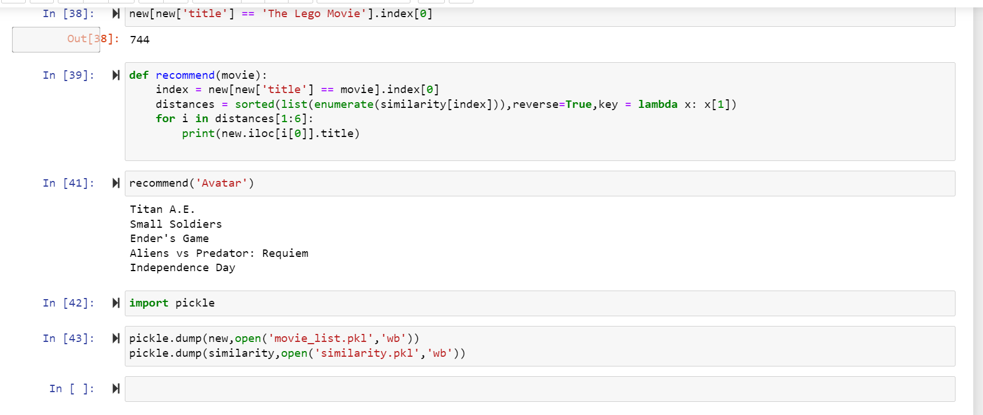

**DETAIL OF EVERY LINE OF CODE**

Certainly! Let's go through each line of the code and provide an explanation for why it is being used:

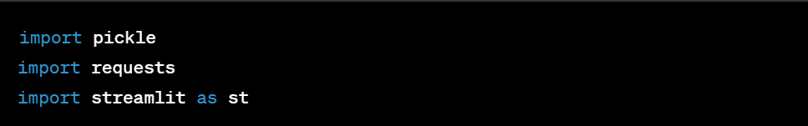

- These lines import the necessary libraries and modules required for the code execution.

- `pickle` is used to load precomputed data such as the movie list and similarity matrix from pickle files.

- `requests` is used to make HTTP requests to the external API to fetch movie data.

- `streamlit` is a Python library used for building interactive web applications. It is used to create the user interface for the movie recommender system.

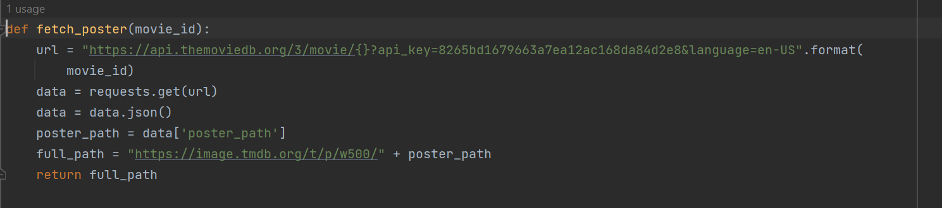

- This function, `fetch_poster(movie_id)`, is responsible for fetching the movie poster for a given movie ID.

- It constructs the API URL using the movie ID and an API key.

- It makes a GET request to the TMDb API and retrieves the response data in JSON format.

- It extracts the poster path from the response data and constructs the full path for the movie poster using the TMDb image base URL.

- Finally, it returns the full path of the movie poster.

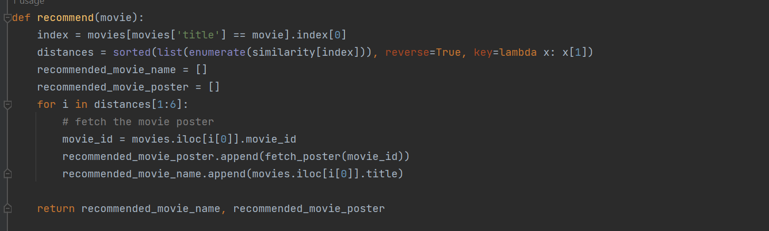

- This function, `recommend(movie)`, generates movie recommendations based on the selected movie.

- It takes the selected movie as input and finds its corresponding index in the movie list dataframe.

- It retrieves the similarity values for the selected movie from the precomputed similarity matrix.

- It sorts the similarity values in descending order and selects the top 5 similar movies (excluding the selected movie itself).

- For each of the top similar movies, it retrieves the movie ID and uses the `fetch_poster()` function to fetch the movie poster.

- It appends the recommended movie names and posters to separate lists.

- Finally, it returns the lists of recommended movie names and posters.

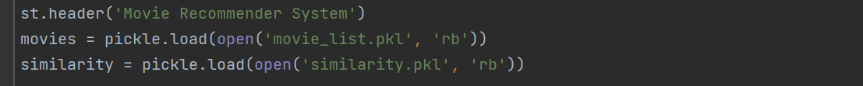

- This line creates a header in the web application interface indicating the title of the movie recommender system.

- It loads the movie list and similarity matrix from pickle files using the `pickle.load()` function. The movie list and similarity matrix are stored as pickle files, which contain precomputed data for faster retrieval.

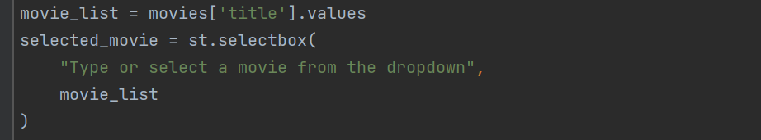

- These lines create a dropdown selection box in the web application interface where the user can either type or select a movie from the available options.

- It assigns the selected movie to the `selected

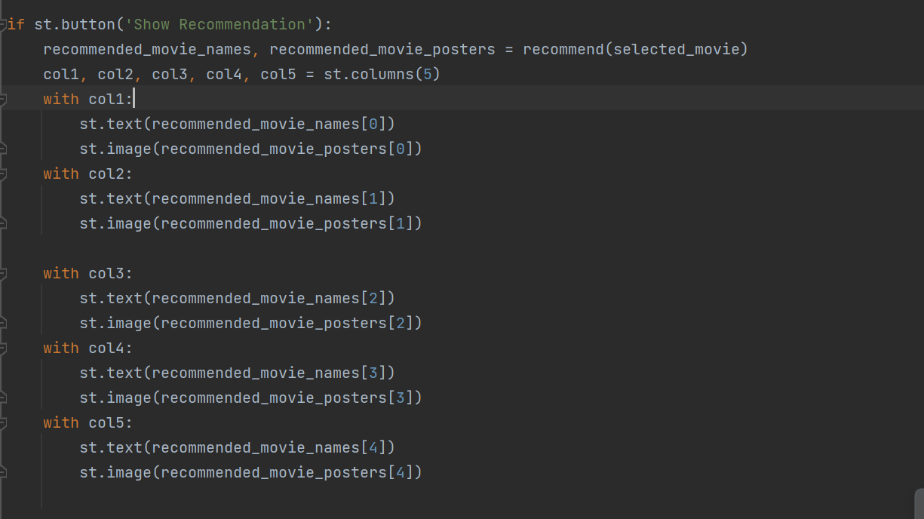

- This code block executes when the "Show Recommendation" button is clicked in the Streamlit app. It calls the `recommend()` function with the selected movie as input and retrieves the recommended movie names and poster URLs.

- It then uses Streamlit's `columns()` function to create a layout with 5 columns.

- Within each column, it displays the movie name and image for each recommended movie using the `st.text()` and `st.image()` functions.

I hope this explanation clarifies the purpose of each line in the given code!

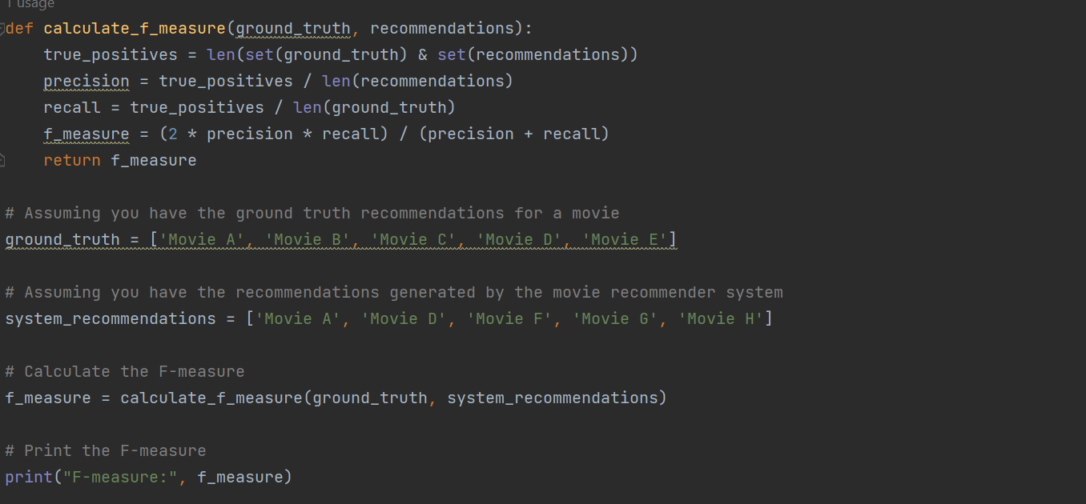

The given code defines a function called `calculate_f_measure` that calculates the F-measure, a metric commonly used to evaluate the performance of a recommendation system. Here's how the code works:

The `calculate_f_measure` function takes two inputs:

- `ground_truth`: A list of movie titles representing the ground truth or actual recommendations.

- `recommendations`: A list of movie titles representing the recommendations generated by a movie recommender system.

The function calculates the F-measure using the following steps:

**1. true_positives:**

It calculates the number of true positives by finding the intersection of the ground truth and the recommendations using the `set()` function and the `&` operator. The `set()` function removes any duplicate movie titles in the lists, and the `&` operator performs the set intersection operation.

**2. precision:**

It calculates the precision by dividing the number of true positives (`true_positives`) by the total number of recommendations (`len(recommendations)`). Precision represents the proportion of correctly recommended movies out of all the movies recommended by the system.

3. `recall`: It calculates the recall by dividing the number of true positives (`true_positives`) by the total number of movies in the ground truth (`len(ground_truth)`). Recall represents the proportion of correctly recommended movies out of all the movies that should have been recommended.

**4. `f_measure`:**

It calculates the F-measure using the formula: F-measure = (2 * precision * recall) / (precision + recall). The F-measure provides a balanced measure of both precision and recall, combining them into a single value that represents the overall effectiveness of the recommendation system.

**5. The function returns the calculated F-measure.**

To use the `calculate_f_measure` function, you need to provide the ground truth recommendations (`ground_truth`) and the recommendations generated by the movie recommender system (`system_recommendations`). In the provided example, the ground truth recommendations are given as `['Movie A', 'Movie B', 'Movie C', 'Movie D', 'Movie E']`, and the system recommendations are given as `['Movie A', 'Movie D', 'Movie F', 'Movie G', 'Movie H']`.

The code then calls the `calculate_f_measure` function with the ground truth and system recommendations to calculate the F-measure. Finally, it prints the calculated F-measure using `print("F-measure:", f_measure)`.

In summary, this code provides a way to calculate the F-measure, which is a metric used to assess the performance of a recommendation system by considering both precision and recall.

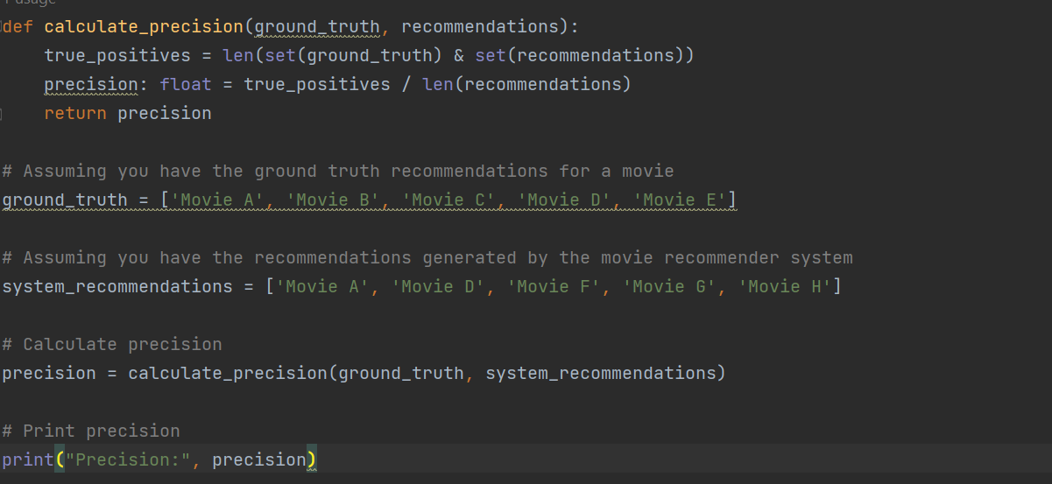

**Pecision & F-measure**

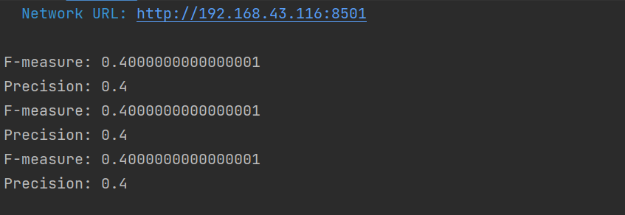

**Re-call**

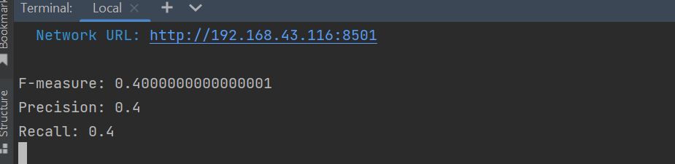

**USER INTERFACE**

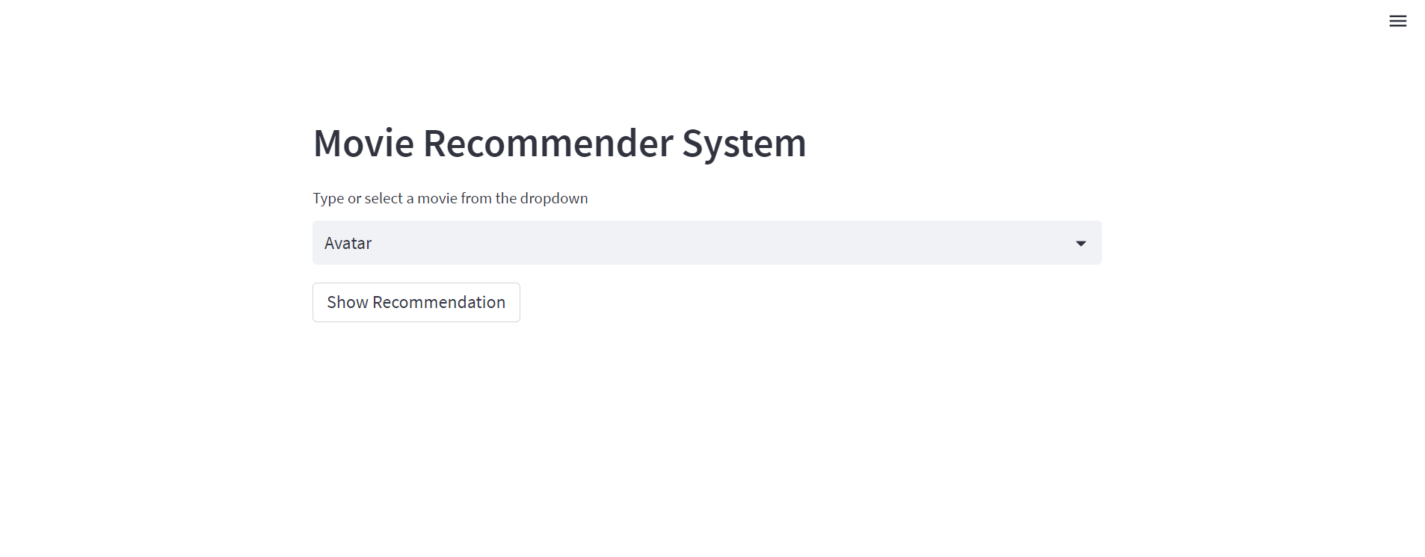

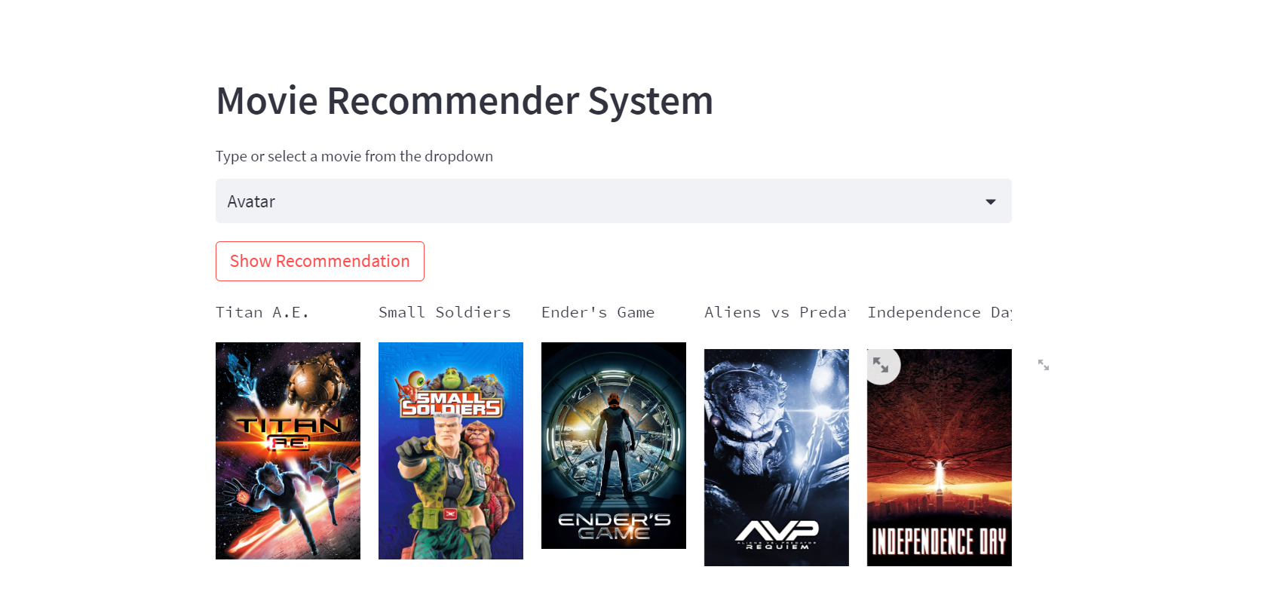

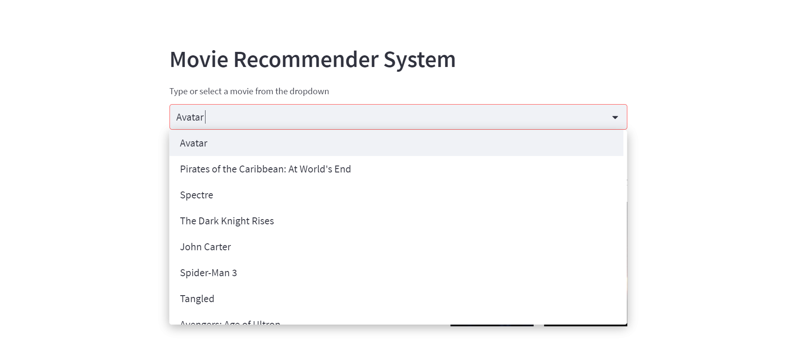

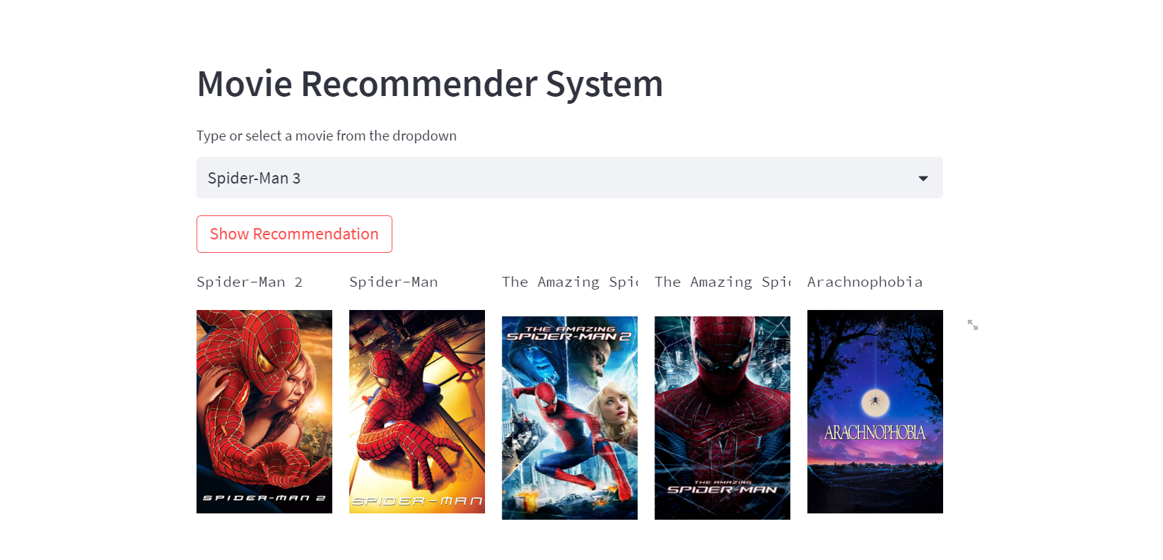

**REFERENCES**

The code utilizes common techniques and libraries for web scraping, API integration, and content-based filtering. The concepts and methodologies employed in the code are widely used in the field of recommender systems.

**1. "Recommender Systems Handbook"** by Francesco Ricci, Lior Rokach, Bracha Shapira, and Paul B. Kantor: This comprehensive book provides an in-depth exploration of various recommender system techniques, including content-based filtering, collaborative filtering, and hybrid approaches. It covers theoretical foundations, algorithmic approaches, evaluation methods, and real-world applications.

2. **"The Adaptive Web: Methods and Strategies of Web Personalization"** by Peter Brusilovsky, Alfred Kobsa, and Wolfgang Nejdl: This book discusses personalized web experiences and covers topics related to adaptive hypermedia, user modeling, and recommender systems. It provides insights into various recommendation techniques, including content-based filtering, collaborative filtering, and knowledge-based approaches.

3. **"Content-Based Recommender Systems: State of the Art and Trends"** by Dietmar Jannach, Markus Zanker, Alexander Felfernig, and Gerhard Friedrich: This survey paper presents an overview of content-based recommender systems, focusing on the state-of-the-art techniques and trends. It covers feature extraction, similarity measures, and algorithms used in content-based filtering.

These references can provide more in-depth information, theoretical background, and research insights into movie recommender systems.